Step 1: Firstly, install VMWare Workstation using the files provided in prerequisites

folder. Then, download the Cloudera extension from the same folder and

extract its contents.

Step 2: After completing the previous step, locate **Open a Virtual Machine** and click

on the option to open it."

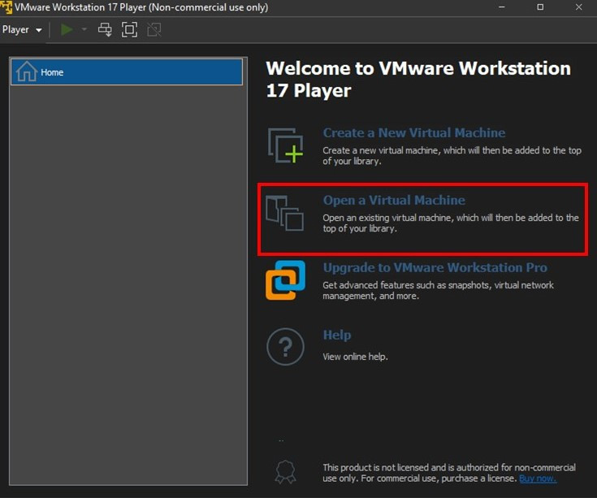

Step 3: To open the **Cloudera VM**, you need to locate the **Cloudera VM** file in your

directory and then access it

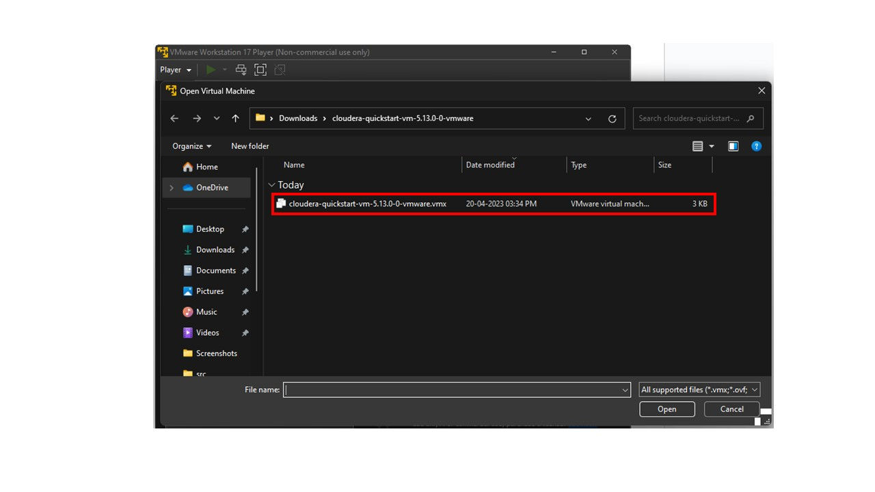

Step 4: Run Cloudera VM

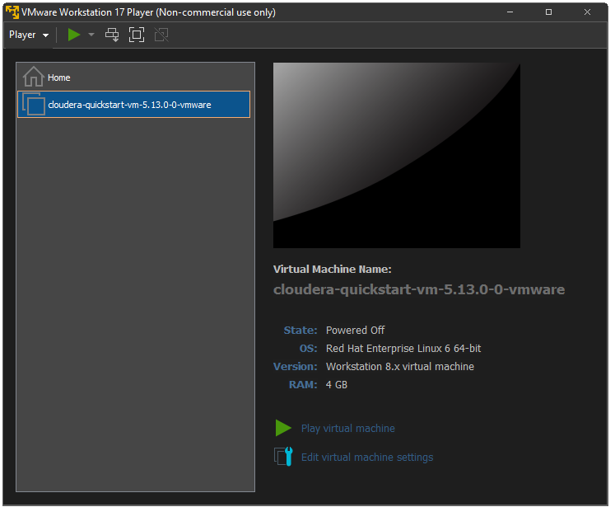

Step 5: If we encounter a database already existing error…

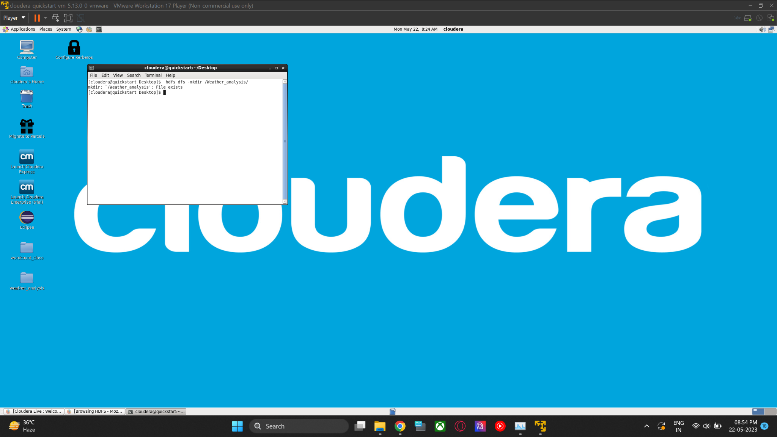

Step 6: To resolve this issue, execute the following command to delete the file from Hadoop.

**$ hadoop fs -rm -r /Weather_analysis**

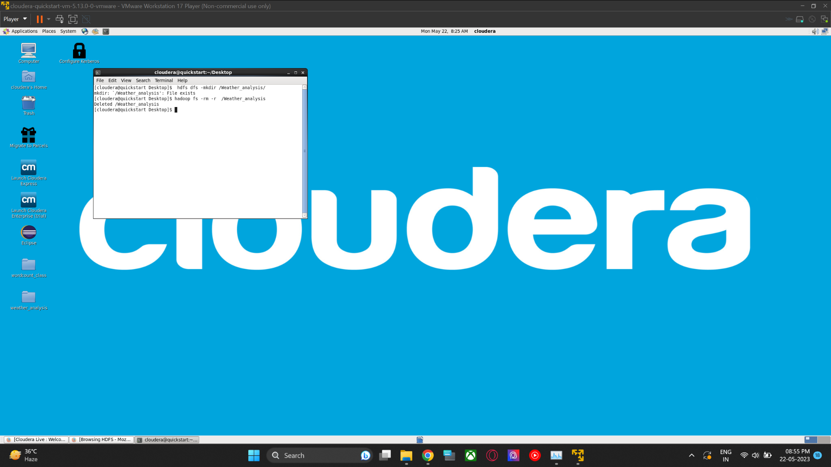

Step 7: Create a folder with name weather analysis in a virtual machine by using following Command.

**$ mkdir weather_analysis**

Step 8: Using the following command, navigate to the directory of the name weather

analysis in a virtual machine.

**$ cd weather_analysis/**

Step 9: Write programs for weather_analysis to find the average for temperature, dew point, and wind speed using the given command, and utilize a text file to count the number of occurrences of each word.

**$ gedit WeatherAnalysis.java**

**$ gedit sample_weather.txt**

Step 10: Create a Hadoop directory for storing the TXT file and then put the TXT file

into that directory by using the given command.

**$ hdfs dfs -mkdir /Weather_analysis/**

**$ hdfs dfs -put sample_weather.txt /Weather_analysis/**

Step 11: Compile the Java files using the following commands, which include the

Hadoop libraries.

**$ javac -cp $(hadoop classpath) *.java**

Step 12:Create a Java archive for distribution using the following command

**$ jar -cvf weather.jar *.class**

Step 13:To run a JAR file in Hadoop and see the average for temperature, dew

point, and wind speed in the TXT file, type the following command:

**$hadoop jar weather.jar WeatherAnalysis /Weather_analysis/sample_weather.txt /Weather_analysis/Output**

**$ hadoop fs -cat /Weather_analysis/Output/part-00000**